**How to Design an Effective Website**

With all the tools on the internet to create websites, it is no longer a difficult task to make a website. What is difficult, however, is creating a website that is both functional as well as good-looking. Nowadays anyone can have a reason to publish a website whether they want to use it to promote a personal business or just to have somewhere to blog about their interest. All you need is a computer and a domain name. From here it may seem easy to create a website with a platform such as Wix where you just have to choose a layout and drop in some content. However, creating an effective website requires that the target audience is identified and the website is planned out accordingly. This can be accomplished by first focusing on the layout of the website and choosing the main typefaces and colors that will be used. This guide assumes that you have some experience in basic web design and therefore will focus on the steps that are necessary to designing a more effective website.

**1. Identify Your Audience**

The first step to creating a functional website is to determine the objective of the website and who is going to use it. This is a crucial step because the design of the whole website will be based on who the intended audience is. There are a few simple questions to ask yourself. What is the purpose of this website? Is it a platform to sell merchandise or is it going to be used as a means of informing an audience? Is it a website for a business and, if so, how formal is the business? The design of a website will vary a lot for two different companies, such as a law firm and a restaurant, since they want to convey two very different messages.

The tone of the website should be considered next which is directly related to the website’s purpose. A banking website will try to show that they are trustworthy and safe, while a blog will be more casual and familiar. In this way, everything from the color palette to the font style will be different as well as how the content on the website is organized. The results of these inquiries will have an intended effect on the audience that will lead to a greater success for the website.

**2. Choose a Platform and Domain Name**

Now that the audience has been identified, you need to examine your own skills and how much effort you want to put into building the website. Website builders such as Wix and Weebly are very user friendly and they generate websites through drag-and-drop gestures and therefore do not require that you have any prior coding experience. This can be seen as both a positive and downfall of these types of platforms. If you choose Wix or Weebly, you have to choose from a list of templates and then you are then stuck with the styling of the template throughout the website.

With other platforms such as WordPress, some of the accessibility is lost in exchange for greater customizability. WordPress can also be used without touching the backend code of the website, but it allows for the code to be edited to increase the functionality of certain aspects of the website. All of these platforms have multiple plans that determine things like how much storage and bandwidth the website has and what options there are for monetization within the website. The cost of these plans varies from completely free to upwards of $25 per month with the most popular options being around the $10 per month mark.

Most of these platforms also include a free domain name. But if it doesn’t, websites like GoDaddy provide domain names for as little as a dollar a year. As far as actually choosing a domain name, it should be something that is memorable, unique, and geared towards the audience of the website. You need to name it something that makes sense for the content of the website while also being original enough that it is available and the users of the website will remember it.

[**https://moz.com/blog/how-to-choose-a-domain-name-whiteboard-friday**](https://moz.com/blog/how-to-choose-a-domain-name-whiteboard-friday)

**3. Create a Mockup**

**What Software to Use**

The next step in creating your website should be to build a mockup for the layout of the website. This will help to ensure that the website appears to be well thought out and not just a jumble of content that was thrown together at the last minute. A good way to do this is could be through a program called Balsamiq which can be found at the website [www.balsamiq.com](http://www.balsamiq.com/) or Invision at [www.invisionapp.com](http://www.invisionapp.com/). Invision is a free app while Balsamiq requires a monthly subscription but has a free trial to start with. Both services make it easy to quickly transfer an idea in your head into something that you can actually look at and share with others. This way you can get feedback on the website and tweak it before the actual implementation begins.

**Effective Page Design**

Before beginning with the design of your website, it is important to understand how users will interpret the website. The first thing to know is that most users will scan a web-page rather than reading it entirely. They will quickly skim the page until they find something important and read outward from that point to understand the context of what they thought was important. In the mockup above, similar content is grouped together in a grid-like structure. This allows a user to quickly interpret the webpage and find what they are looking for.

The content is divided by visible boxes. However, in the final version of the website, the separation be white space which will make the layout look simpler and cleaner. Another important aspect of page design is highlighting, a design technique that is used to make the most important parts, or the parts that you want the user to look at, catch the attention of the user. This can be accomplished in a variety of ways including using bright colors or bold text. Highlighting in combination with utilizing white space results in a clean looking website that is easy to navigate and read. Once one page is created using these principles, the other pages of the website should mimic the same style.

<https://www.smashingmagazine.com/2008/01/10-principles-of-effective-web-design/>

**4. Choose a Color Scheme**

The color scheme is a crucial aspect of a website and it is one of the major things that people mess up when creating their website. A bad color palette can make a website unappealing to look at or difficult to read while an effective color palette has the ability to evoke certain emotions in your audience.

Red, as shown in the Red Bull logo, is often associated with energy, strength, power and danger, all of which are what Red Bull wants to convey to its consumers. John Deere, on the other hand, wants to show its safe, stable and environmentally friendly side which are often associated with the color green. The color most associated with corporate America is blue which can also elicit feelings of wisdom, confidence and intelligence. Nasa uses the color blue to display that, although it really is rocket science, they can handle it. Each of these three companies accomplish three very different tasks and therefore use three very different color palettes. Some other popular colors include yellow, representing happiness and energy, purple, showing luxury and wisdom, white, which represents innocence and purity, and black for elegance, formality and mystery.

Unless your company already has a colored logo, you should choose a primary color based on these color interpretations. Do you want to display safety and professionalism to your users or do you want to focus more on being seen as a more personal company? Be sure to also consider what you are selling. If it’s food, you might want to use green to represent freshness. If it’s a service, colors like black and blue will promote a sense of wisdom and professionalism and the ability to get the job done correctly.

Using one or two primary colors, you can use a program such as Adobe Color CC at [color.adobe.com](https://color.adobe.com/) in order to choose a color scheme. Similar to your page design, once you choose a color scheme, you should stick to it throughout the website.

[**http://www.color-wheel-pro.com/color-meaning.html**](http://www.color-wheel-pro.com/color-meaning.html)

**5. Choose Fonts**

Similar to colors, there is also a psychological effect of fonts. Some fonts are easier to read than others and different fonts are associated with different feelings.

The font used by the law firm is categorized as serif font which means it has lines coming off the edges of the letters. Serif font is often viewed as more formal and easier to read so it is best suited for bodies of text. In this case, Hacker Law Firm wants to show professionalism and formality since these are very important attributes of a company dealing with the law. Hulu opts for sans-serif font revealing that it is a modern and progressive company while Disney uses a bold decorative font to showcase its fun and happy features which makes it easily recognizable.

While serif is thought to be easier to read, the serifs don’t show up as well on digital media as well as they do on printed material. Therefore, sans-serif is normally used for bodies of text on websites while serif fonts can be used as a contrast to show something is important such as headings. In terms of the specific fonts to use for your website, it mostly just depends on what looks best in the context of the surrounding design choices. In general, you should stick to only a few different styles throughout the website to maintain consistency and ensure that everything flows together and is easy to read.

Another thing to consider is typographic hierarchy which is when different sizes and weights of font are used in order to show importance and better organize the layout of the website. Similar to how different font sizes and styles are used in this document, typographic hierarchy makes it easier for the user to navigate through a document or a website.

[**http://visual.ly/fonts-and-feelings-psychology-typography**](http://visual.ly/fonts-and-feelings-psychology-typography)

**6. How to Create the Final Product**

Now that most of the design choices for your website have been chosen, it’s time to put it all together along with the content in order to create the final product. This can either be done in the drag-and-drop style of Wix or with HTML and CSS in a program like WordPress. Using this platform and the mockup of the site you can now start to decide on the actual content that will be added to the webpages. The final website doesn’t need to be an exact implementation of the mock up. You should follow the it as a guideline, but make sure to try out new things to see what works the best.

First, divide the content into different sections and use the above steps as a guideline for what colors and fonts to use. In general, a minimalistic design style is the most widely accepted style. This means that you should not use a

http://www.riversideartcenter.org/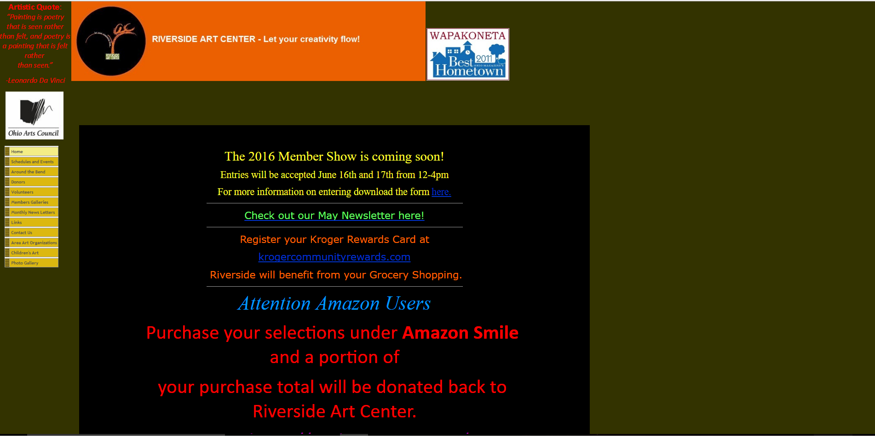

**http://www.spacex.com/**